Guide: Comparison of Results against Previous Years
2015-2016

Strategy and Future Department
Concerned Parties Satisfaction Division

REPORT CONTENTS

Executive Summary
Comparison of Concerned Segments' Satisfaction Results
Comparison of Mystery Shopper Results
Comparison of Employee Satisfaction Study Results

- Comparison of Concerned Segments' Satisfaction Results:

Smart applications – social media – website – customer satisfaction with call center – report of the partners in provision of services in the field of smart transformation – strategic partner satisfaction – employer satisfaction – supplier satisfaction – representative satisfaction

- Mystery Shopper

- Employee Satisfaction

COMPARISON OF RESULTS OF CONCERNED SEGMENTS' SATISFACTION
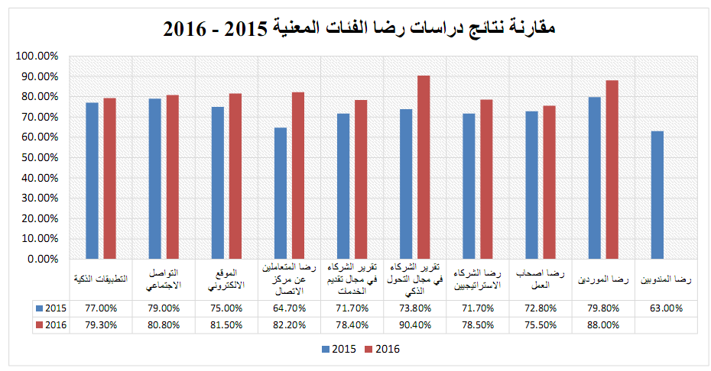
Comparison of Concerned Segments' Satisfaction Study Results 2015-2016
Smart Applications
Social Media
Website
Customer Satisfaction with Call Center
Report of Service Provision Partners
Report of Smart Transformation Partners
Strategic Partner Satisfaction
Employer Satisfaction
Supplier Satisfaction
Representative Satisfaction
[Type a quote from the document or the summary of an interesting point. You can position the text box anywhere in the document. Use the Text Box Tools tab to change the formatting of the pull quote text box.]
COMPARISON OF MYSTERY SHOPPER SATISFACTION STUDY RESULTS
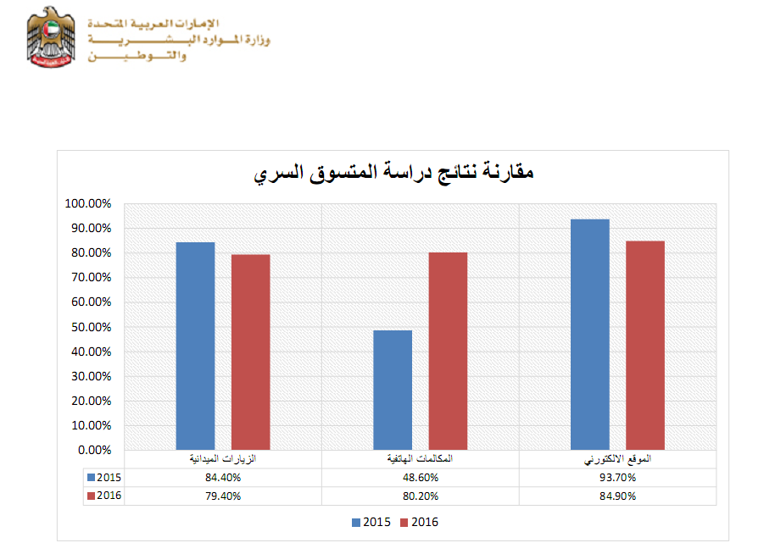
Comparison of Mystery Shopper Study Results
Field Visits
Call Phones
Website

COMPARISON OF EMPLOYEE SATISFACTION STUDY RESULTS

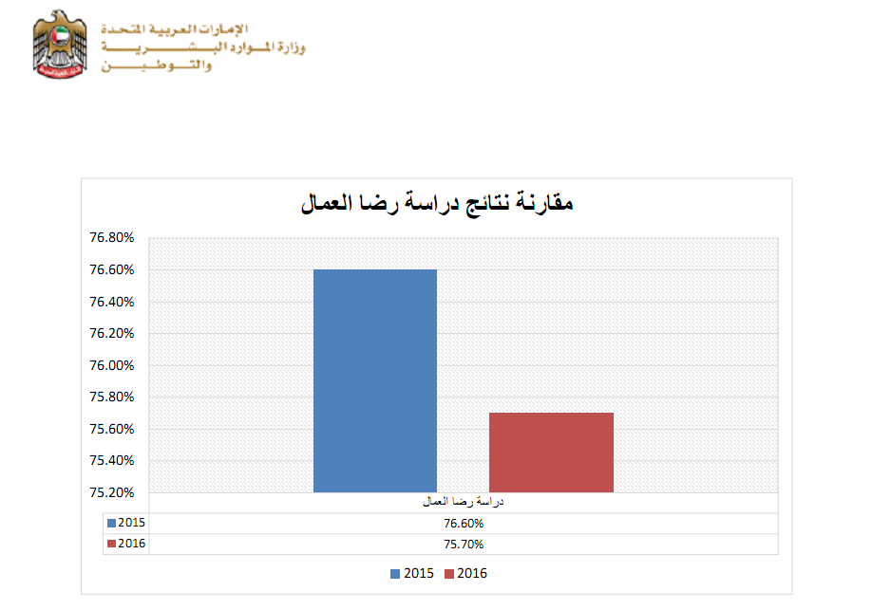
Comparison of Employee Satisfaction Study Results
Employee Satisfaction Study

THANK YOU

