WEBSITE REPORT
Implemented by
Ethos Integrated Solutions

Presentation Content

- Introduction and Objectives of Study
- Research and Assessment Methodology

- Website Questionnaire
- Sample Distribution
- General Satisfaction Result
- Satisfaction as per Demographic Distribution
- Satisfaction with Topics
- Customer Feedback

Introduction and Objectives of Study

Within the framework of the Ministry of Human Resources and Emiratisation (MOHRE) in general, and the Corporate Excellence Department in particular, with "Ethos Integrated Solutions", and as a part of the Ministry's permanent strive for excellence, and keenness to measure customer satisfaction with its performance, the Company conducts a customer's questionnaire to measure satisfaction with the Ministry's performance and variety of services throughout the country.

Strategic Objectives
- To improve performance and activate its role in achieving the Ministry's objectives.
- To activate communication with MOHRE's customers.
- To identify customer needs expectations, satisfaction and suggestions for improvement of services.

Introduction and Objectives of Study

Determination of Study Objectives | Design of Questionnaire according to Required Criteria | Starting Data Collection | Data Entry | Necessary Data Analysis and Presentation of Results | Preparation of Final Report and Writing Recommendation
- Questionnaires have been designed in cooperation with the concerned department in line with the study objectives. |  | - Data was collected through: |  | - The data has been put to necessary analysis and questionnaire results have been found as per the method mentioned in the preceding slide.
- A primary draft was sent and approved by the Department. |  | - E-questionnaire: the questionnaires have been uploaded on the system and the link has been shared with the customers and concerned persons to fill in the questionnaire. |  | - The results have been shared with the concerned department for approval and uploading on MOHRE's system.
- Questionnaires were uploaded on the questionnaire system of Ethos. |  | Data and information that has been collected personally and by phone has been entered in the system. |  | - The final report format has been agreed on and prepared as per the Department's requirements.

Research and Assessment Methodology

- 5-mark designed questionnaires have been used (Likert Scale)
- The graded scale has been used as follows:

Selection |  | No. of Points
Highly Satisfied | Quite Approved | 4
Satisfied | Approved | 3
Neutral | Neutral | 2
Unsatisfied | Unapproved | 1
Very Unsatisfied | Absolutely Disagree | 0
Inapplicable to this question | Inapplicable to this question | No Points

- When surveying the customer satisfaction for the time spent in the service, the ideal result is "Highly Satisfied", which gives the Department 4 points. If the customer answers "Unsatisfied", only one point is only granted to get satisfaction ratio to be calculated by the percentage of (the points actually granted to the points accounting for the ideal result): 1/4: 20% satisfaction ratio.

Research and Assessment Methodology

Another Example: when surveying the satisfaction of 10 customers for the time spent in obtaining the service, the ideal result is that they are "Highly Satisfied", which gives the Department 40 points. Suppose that their actual result is that five of them are "unsatisfied" and others 5 are "satisfied".

The first part gives the department 5 answers * one point = 5 points

The second part gives the department 5 answers * 3 points = 15 points

Total actually granted points: 5 + 15 = 20 points

To calculate satisfaction ratio, we calculate (the percentage of actually granted points to the points accounting for the ideal result) as 20/40 = 50% satisfaction ratio for the time spent in obtaining the service.

DEMOGRAPHIC DATA

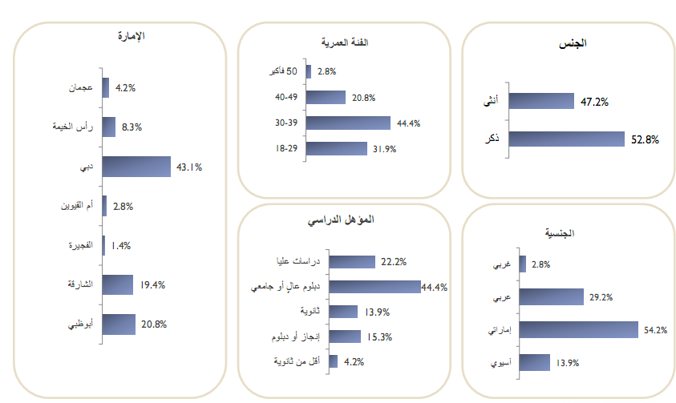
Emirate
Age Segment
Gender

50 or more
Ajman
Female
Ras Al Khaimah
Dubai
Umm Al Qaiwain
Fujairah
Sharjah
Abu Dhabi
Male
Post-graduate studies
High or university diploma
Secondary
Medium grade or diploma
Below-secondary
Asian
Nationality
Academic Qualification
Western
Arab
UAE

GENERAL SATISFACTION RESULT

General Satisfaction

A website questionnaire has been conducted for a general satisfaction that reached 81.5% | 83.7% | Variety of available communication channels.
 | 83.3% | Feeling of confidence and safety in dealing with MOHRE's electronic services.
 | 83.0% | Generally, to which extent you are satisfied with MOHRE's website?
 | 81.7% | Up-to-dateness of information published on the website.
 | 81.4% | Efficiency of services provided on the website.
 | 81.4% | An attractive design of MOHRE's website.
 | 81.1% | Easy-to-use website.
 | 76.1% | MOHRE's quick response with the communications and enquiries received from you via the website.
 | 81.5% | Total Percentage

CUSTOMER FEEDBACK
Customer Feedback

- The website information is corresponding to all service channels in terms of the documents required for transactions.
- The processing of all sent transactions is fast.
- A MOHRE employee is designated to handle the large needs of the Company in case of any hardships.
- Some services are made available to employers such as the issuance of employee's statement and details and provision of data to all users such as printing employee's details and employment contract instead of visiting Tasheel Centers to save time.
- I suggest that a form is developed for employees' leave requests as we have trouble with the Wage Protection Department as to those operating outside the country because they get leave pay without a bank transfer. Therefore, a ban is imposed on the Company, especially the companies with large numbers.
- The customers should be informed of any changes to laws and new procedures.
- MOHRE's website is crowded with information and icons. Comprehensiveness should be put into focus with a space for a reader's eye.
- In case of several permits, the employee's name should be determined on the receipt.
- The several options and headings on the interface are dispersive. We recommend that the interface contains photos of MOHRE's works or achievements.
- There should be a chance to print the escape report to complete procedures with the General Directorate of Residency and Foreigners Affairs.
- Transactions should be carried out via the website instead of visiting the Center to save time.
- FAQ should be enhanced to include all topics related to Labor Law enquiries. Thank You.
- Please avoid electronic updates during official working hours. This cripples work.
- MOHRE should quickly respond to the complaints and enquiries sent via the website and live chat with the employee is added.

THANK YOU

